Федеральное государственное бюджетное образовательное учреждение

высшего образования

«Российский экономический университет им. Г.В. Плеханова»

Московский приборостроительный техникум

Специальность: 09.02.07 Информационные системы и программирование

Квалификация: Программист

Общепрофессиональная дисциплина: ОП 08 Основы проектирования баз данных

МПТ.09.02.07-П.ОП.08.ОПБД.П50-7-20.10.22

Отчёт к практической работе № 8

«Реализация таблиц и ограничений в базе данных»

Тема: «Разработка базы данных на примере предметной области: ««Ресторан». Реализация

подсистем: учёт и обработка заказов, учёт и реализация меню».

|  |  |
| --- | --- |
| Проверил: | Выполнил: |
| Щаников И.М.__________ | Студент группы |
| (________)_____________ | П50-7-20 |
| «___»_____________2022г. | ____________Огурцов А.А. |
|  | «___»_____________2022г. |

2022

СОДЕРЖАНИЕ

1. ЦЕЛИ ПРАКТИЧЕСКОЙ РАБОТЫ 3

2. ЭТАПЫ ВЫПОЛНЕНИЯ 4

3. ВЫВОД 5

4. СПИСОК ИСПОЛЬЗУЕМЫХ МАТЕРИАЛОВ 6

1. ЦЕЛИ ПРАКТИЧЕСКОЙ РАБОТЫ

На основании даталогической модели данных и словаря данных, разработать структуру таблиц базы данных, на сервере СУБД.

ЭТАПЫ ВЫПОЛНЕНИЯ

1. Иллюстрация диагнраммы базы данных;

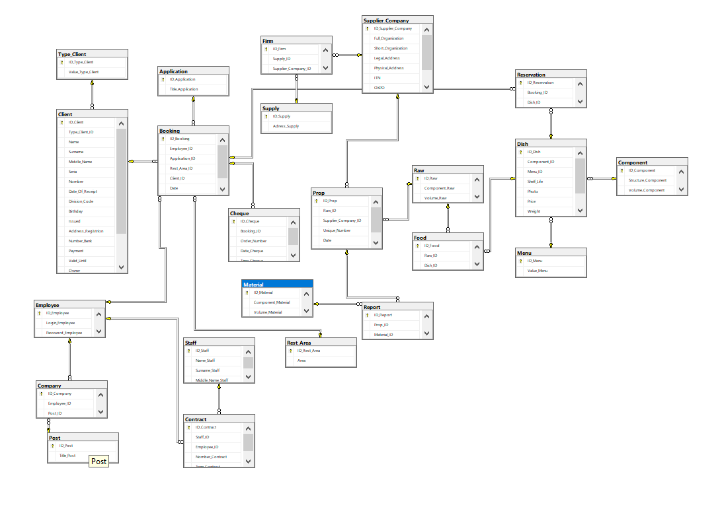

1. К каждой таблице базы данных, необходимо реализовать минимум по 3 – и хранимые процедуры, на добавление, изменение, удаление данных (при этом одна функция может включать в себя сразу несколько действий, к разным таблицам).

|  |  |
| --- | --- |
| Скрипт таблицы | Хранимая процедура на добавление данных |
| create table [dbo].[Type_Client]  (  [ID_Type_Client] [int] not null identity(1,1),  [Value_Type_Client] [varchar] (10) not null  constraint [PK_Type_Client] primary key clustered  ([ID_Type_Client] ASC) on [PRIMARY],  constraint [UQ_Value_Type_Client_Type_Client] unique ([Value_Type_Client])  )  go | create or alter procedure [dbo].[Type_Client_insert]  @Value_Type_Client [varchar] (10)  as  begin try  insert into [dbo].[Type_Client] ([Value_Type_Client])  values (@Value_Type_Client)  end try  begin catch  print('Данный вид клиента уже есть в таблице!')  end catch  go |
| Хранимая процедура на изменение данных |
| create or alter procedure [dbo].[Type_Client_update]  @ID_Type_Client [int], @Value_Type_Client [varchar] (10)  as  begin try  update [dbo].[Type_Client] set  [Value_Type_Client] = @Value_Type_Client  where  [ID_Type_Client] = @ID_Type_Client  end try  begin catch  print('Данный вид клиента уже есть в таблице!')  end catch  go |
| Хранимая процедура на удаление данных |
| create or alter procedure [dbo].[Type_Client_delete]  @ID_Type_Client [int]  as  declare @any_child_record [int] = (select count(*) from [dbo].[Client]  where [Type_Client_ID] = @ID_Type_Client)  if (@any_child_record > 0)  print('Тип клиента не может удалён, так как в таблице "Тип клиента", есть связанные данные!');  else  delete from [dbo].[Type_Client]  where  [ID_Type_Client] = @ID_Type_Client  go |
| Скрипт таблицы | Хранимая процедура на добавление данных |
| create table [dbo].[Post]  (  [ID_Post] [int] not null identity(1,1),  [Title_Post] [varchar] (32) not null  constraint [PK_Post] primary key clustered  ([ID_Post] ASC) on [PRIMARY],  constraint [UQ_Title_Post_Post] unique ([Title_Post])  )  go | create or alter procedure [dbo].[Post_insert]  @Title_Post [varchar] (32)  as  begin try  insert into [dbo].[Post] ([Title_Post])  values (@Title_Post)  end try  begin catch  print('Данная должность уже есть в таблице!')  end catch  go |
| Хранимая процедура на изменение данных |
| create or alter procedure [dbo].[Post_update]  @ID_Post [int], @Title_Post [varchar] (32)  as  begin try  update [dbo].[Post] set  [Title_Post] = @Title_Post  where  [ID_Post] = @ID_Post  end try  begin catch  print('Данная должность уже есть в таблице!')  end catch  go |
| Хранимая процедура на удаление данных |
| create or alter procedure [dbo].[Post_delete]  @ID_Post [int]  as  declare @any_child_record [int] = (select count(*) from [dbo].[Company]  where [Post_ID] = @ID_Post)  if (@any_child_record > 0)  print('Должность не может быть удалена удалён, так как в таблице "Должность", есть связанные данные!');  else  delete from [dbo].[Post]  where  [ID_Post] = @ID_Post  go |
| Скрипт таблицы | Хранимая процедура на добавление данных |
| create table [dbo].[Menu]  (  [ID_Menu] [int] not null identity(1,1),  [Value_Menu] [varchar] (max) not null  constraint [PK_Menu] primary key clustered  ([ID_Menu] ASC) on [PRIMARY]  )  go | create or alter procedure [dbo].[Menu_insert]  @Value_Menu [varchar] (max)  as  begin try  insert into [dbo].[Menu] ([Value_Menu])  values (@Value_Menu)  end try  begin catch  print('Данное название блюда уже есть в таблице!')  end catch  go |
| Хранимая процедура на изменение данных |
| create or alter procedure [dbo].[Menu_update]  @ID_Menu [int], @Value_Menu [varchar] (max)  as  begin try  update [dbo].[Menu] set  [Value_Menu] = @Value_Menu  where  [ID_Menu] = @ID_Menu  end try  begin catch  print('Данное название блюда уже есть в таблице!')  end catch  go |
| Хранимая процедура на удаление данных |
| create or alter procedure [dbo].[Menu_delete]  @ID_Menu [int]  as  declare @any_child_record [int] = (select count(*) from [dbo].[Dish]  where [Menu_ID] = @ID_Menu)  if (@any_child_record > 0)  print('Название блюда не может быть удалена удалён, так как в таблице "Меню", есть связанные данные!');  else  delete from [dbo].[Menu]  where  [ID_Menu] = @ID_Menu  go |
| Скрипт таблицы | Хранимая процедура на добавление данных |
| create table [dbo].[Component]  (  [ID_Component] [int] not null identity(1,1),  [Structure_Component] [varchar] (32) not null,  [Volume_Component] [int] not null  constraint [PK_Component] primary key clustered  ([ID_Component] ASC) on [PRIMARY],  constraint [UQ_Structure_Component_Component] unique ([Structure_Component]),  constraint [CH_Volume_Component_Component] check ([Volume_Component] > 0)  )  go | create or alter procedure [dbo].[Component_insert]  @Structure_Component [varchar] (32),@Volume_Component [int]  as  begin try  insert into [dbo].[Component] ([Structure_Component], [Volume_Component])  values (@Structure_Component, @Volume_Component)  end try  begin catch  print('Данный компонент уже есть в таблице!')  end catch  go |
| Хранимая процедура на изменение данных |
| create or alter procedure [dbo].[Component_update]  @ID_Component [int],@Structure_Component [varchar] (32),@Volume_Component [int]  as  begin try  update [dbo].[Component] set  [Structure_Component] = @Structure_Component,  [Volume_Component] = @Volume_Component  where  [ID_Component] = @ID_Component  end try  begin catch  print('Данный компонент уже есть в таблице!')  end catch  go |
| Хранимая процедура на удаление данных |
| create or alter procedure [dbo].[Component_delete]  @ID_Component [int]  as  declare @any_child_record [int] = (select count(*) from [dbo].[Dish]  where [Component_ID] = @ID_Component)  if (@any_child_record > 0)  print('Компонент не может быть удалена удалён, так как в таблице "Компонент", есть связанные данные!');  else  delete from [dbo].[Component]  where  [ID_Component] = @ID_Component  go |
| Скрипт таблицы | Хранимая процедура на добавление данных |
| create table [dbo].[Raw]  (  [ID_Raw] [int] not null identity(1,1),  [Component_Raw] [varchar] (32) not null,  [Volume_Raw] [int] not null  constraint [PK_Raw] primary key clustered  ([ID_Raw] ASC) on [PRIMARY],  constraint [UQ_Component_Raw_Raw] unique ([Component_Raw]),  constraint [CH_Volume_Raw_Raw] check ([Volume_Raw] > 0)  )  go | create or alter procedure [dbo].[Raw_insert]  @Component_Raw [varchar] (32),@Volume_Raw [int]  as  begin try  insert into [dbo].[Raw] ([Component_Raw], [Volume_Raw])  values (@Component_Raw, @Volume_Raw)  end try  begin catch  print('Данное сырьё уже есть в таблице!')  end catch  go |
| Хранимая процедура на изменение данных |
| create or alter procedure [dbo].[Raw_update]  @ID_Raw [int],@Component_Raw [varchar] (32),@Volume_Raw [int]  as  begin try  update [dbo].[Raw] set  [Component_Raw] = @Component_Raw,  [Volume_Raw] = @Volume_Raw  where  [ID_Raw] = @ID_Raw  end try  begin catch  print('Данное сырьё уже есть в таблице!')  end catch  go |
| Хранимая процедура на удаление данных |
| create or alter procedure [dbo].[Raw_delete]  @ID_Raw [int]  as  declare @any_child_record1 [int] = (select count(*) from [dbo].[Prop]  where [Raw_ID] = @ID_Raw)  declare @any_child_record [int] = (select count(*) from [dbo].[Food]  where [Raw_ID] = @ID_Raw)  if (@any_child_record >0 or @any_child_record1 > 0)  print('Компонент не может быть удалена удалён, так как в таблице "Компонент", есть связанные данные!');  else  delete from [dbo].[Raw]  where  [ID_Raw] = @ID_Raw  go |
| Скрипт таблицы | Хранимая процедура на добавление данных |
| create table [dbo].[Material]  (  [ID_Material] [int] not null identity(1,1),  [Component_Material] [varchar] (32) not null,  [Volume_Material] [int] not null  constraint [PK_Material] primary key clustered  ([ID_Material] ASC) on [PRIMARY],  constraint [UQ_Component_Material_Material] unique ([Component_Material]),  constraint [CH_Volume_Material_Material] check ([Volume_Material] > 0)  )  go | create or alter procedure [dbo].[Material_insert]  @Component_Material [varchar] (32),@Volume_Material [int]  as  begin try  insert into [dbo].[Material] ([Component_Material], [Volume_Material])  values (@Component_Material, @Volume_Material)  end try  begin catch  print('Данный материал уже есть в таблице!')  end catch  go |
| Хранимая процедура на изменение данных |
| create or alter procedure [dbo].[Material_update]  @ID_Material [int],@Component_Material [varchar] (32),@Volume_Material [int]  as  begin try  update [dbo].[Material] set  [Component_Material] = @Component_Material,  [Volume_Material] = @Volume_Material  where  [ID_Material] = @ID_Material  end try  begin catch  print('Данный материал уже есть в таблице!')  end catch  go |
| Хранимая процедура на удаление данных |
| create or alter procedure [dbo].[Material_delete]  @ID_Material [int]  as  declare @any_child_record [int] = (select count(*) from [dbo].[Report]  where [Material_ID] = @ID_Material)  if (@any_child_record > 0)  print('Материал не может быть удалена удалён, так как в таблице "Компонент", есть связанные данные!');  else  delete from [dbo].[Material]  where  [ID_Material] = @ID_Material  go |
| Скрипт таблицы | Хранимая процедура на добавление данных |
| create table [dbo].[Application]  (  [ID_Application] [int] not null identity(1,1),  [Title_Application] [varchar] (25) not null  constraint [PK_Application] primary key clustered  ([ID_Application] ASC) on [PRIMARY],  constraint [UQ_Title_Application_Application] unique ([Title_Application])  )  go | create or alter procedure [dbo].[Application_insert]  @Title_Application [varchar] (25)  as  begin try  insert into [dbo].[Application] ([Title_Application])  values (@Title_Application)  end try  begin catch  print('Данная заявка уже есть в таблице!')  end catch  go |
| Хранимая процедура на изменение данных |
| create or alter procedure [dbo].[Application_update]  @ID_Application [int],@Title_Application [varchar] (25)  as  begin try  update [dbo].[Application] set  [Title_Application] = @Title_Application  where  [ID_Application] = @ID_Application  end try  begin catch  print('Данная заявка уже есть в таблице!')  end catch  go |
| Хранимая процедура на удаление данных |
| create or alter procedure [dbo].[Application_delete]  @ID_Application [int]  as  declare @any_child_record [int] = (select count(*) from [dbo].[Booking]  where [Application_ID] = @ID_Application)  if (@any_child_record > 0)  print('Заявка не может быть удалена удалён, так как в таблице "Компонент", есть связанные данные!');  else  delete from [dbo].[Application]  where  [ID_Application] = @ID_Application  go |
| Скрипт таблицы | Хранимая процедура на добавление данных |
| create table [dbo].[Employee]  (  [ID_Employee] [int] not null identity(1,1),  [Login_Employee] [varchar] (32) not null,  [Password_Employee] [varchar] (32) not null  constraint [PK_Employee] primary key clustered  ([ID_Employee] ASC) on [PRIMARY],  constraint [UQ_Login_Employee_Employee] unique ([Login_Employee]),  constraint [CH_Login_Employee_Employee] check (len([Login_Employee])>=8),  constraint [CH_Password_Employee_Employee_Upper] check ([Password_Employee] like ('%[A-Z]%')),  constraint [CH_Password_Employee_Employee_Letter_Lower] check ([Password_Employee] like ('%[a-z]%')),  constraint [CH_Password_Employee_Employee_Symbols] check ([Password_Employee] like ('%[!@#$%^&*()]%'))  )  go | create or alter procedure [dbo].[Employee_insert]  @Login_Employee [varchar] (32),@Password_Employee [varchar] (32)  as  begin try  insert into [dbo].[Employee] ([Login_Employee], [Password_Employee])  values (@Login_Employee, @Password_Employee)  end try  begin catch  print('Данный Работник уже есть в таблице!')  end catch  go |
| Хранимая процедура на изменение данных |
| create or alter procedure [dbo].[Employee_update]  @ID_Employee [int],@Login_Employee [varchar] (32),@Password_Employee [varchar] (32)  as  begin try  update [dbo].[Employee] set  [Login_Employee] = @Login_Employee,  [Password_Employee] = @Password_Employee  where  [ID_Employee] = @ID_Employee  end try  begin catch  print('Данный Работник уже есть в таблице!')  end catch  go |
| Хранимая процедура на удаление данных |
| create or alter procedure [dbo].[Employee_delete]  @ID_Employee [int]  as  declare @any_child_record [int] = (select count(*) from [dbo].[Booking]  where [Employee_ID] = @ID_Employee)  declare @any_child_record1 [int] = (select count(*) from [dbo].[Contract]  where [Employee_ID] = @ID_Employee)  declare @any_child_record2 [int] = (select count(*) from [dbo].[Company]  where [Employee_ID] = @ID_Employee)  if (@any_child_record > 0 or @any_child_record1 > 0 or @any_child_record2 > 0)  print('Работник не может быть удалён, так как в таблице "Работник", есть связанные данные!');  else  delete from [dbo].[Employee]  where  [ID_Employee] = @ID_Employee  go |
| Скрипт таблицы | Хранимая процедура на добавление данных |
| create table [dbo].[Staff]  (  [ID_Staff] [int] not null identity(1,1),  [Name_Staff] [varchar] (30) not null,  [Surname_Staff] [varchar] (30) not null,  [Middle_Name_Staff] [varchar] (30) not null  constraint [PK_Staff] primary key clustered  ([ID_Staff] ASC) on [PRIMARY]  )  go | create or alter procedure [dbo].[Staff_insert]  @Name_Staff [varchar] (30),@Surname_Staff [varchar] (30)  as  begin try  insert into [dbo].[Staff] ([Name_Staff], [Surname_Staff])  values (@Name_Staff, @Surname_Staff)  end try  begin catch  print('Данный Персонал уже есть в таблице!')  end catch  go |
| Хранимая процедура на изменение данных |
| create or alter procedure [dbo].[Staff_update]  @ID_Staff [int],@Name_Staff [varchar] (32),@Surname_Staff [varchar] (32)  as  begin try  update [dbo].[Staff] set  [Name_Staff] = @Name_Staff,  [Surname_Staff] = @Surname_Staff  where  [ID_Staff] = @ID_Staff  end try  begin catch  print('Данный Персонал уже есть в таблице!')  end catch  go |
| Хранимая процедура на удаление данных |
| create or alter procedure [dbo].[Staff_delete]  @ID_Staff [int]  as  declare @any_child_record [int] = (select count(*) from [dbo].[Contract]  where [Staff_ID] = @ID_Staff)  if (@any_child_record > 0)  print('Персонал не может быть удалён, так как в таблице "Персонал", есть связанные данные!');  else  delete from [dbo].[Staff]  where  [ID_Staff] = @ID_Staff  go |
| Скрипт таблицы | Хранимая процедура на добавление данных |
| create table [dbo].[Rest_Area]  (  [ID_Rest_Area] [int] not null identity(1,1),  [Area] [varchar] (30) not null  constraint [PK_Rest_Area] primary key clustered  ([ID_Rest_Area] ASC) on [PRIMARY],  constraint [UQ_Area_Rest_Area] unique ([Area])  )  go | create or alter procedure [dbo].[Rest_Area_insert]  @Area [varchar] (30)  as  begin try  insert into [dbo].[Rest_Area] ([Area])  values (@Area)  end try  begin catch  print('Данная зона уже есть в таблице!')  end catch  go |
| Хранимая процедура на изменение данных |
| create or alter procedure [dbo].[Rest_Area_update]  @ID_Rest_Area [int],@Area [varchar] (30)  as  begin try  update [dbo].[Rest_Area] set  [Area] = @Area  where  [ID_Rest_Area] = @ID_Rest_Area  end try  begin catch  print('Данная зона уже есть в таблице!')  end catch  go |
| Хранимая процедура на удаление данных |
| create or alter procedure [dbo].[Rest_Area_delete]  @ID_Rest_Area [int]  as  declare @any_child_record [int] = (select count(*) from [dbo].[Booking]  where [Rest_Area_ID] = @ID_Rest_Area)  if (@any_child_record > 0)  print('Зона не может быть удалён, так как в таблице "Персонал", есть связанные данные!');  else  delete from [dbo].[Rest_Area]  where  [ID_Rest_Area] = @ID_Rest_Area  go |
| Скрипт таблицы | Хранимая процедура на удаление данных |
| create table [dbo].[Supplier_Company]  (  [ID_Supplier_Company] [int] not null identity(1,1),  [Full_Organization] [varchar] (32) not null,  [Short_Organization] [varchar] (32) not null,  [Legal_Address] [varchar] (max) not null,  [Physical_Address] [varchar] (max) not null,  [ITN] [varchar] (12) not null,  [OKPO] [varchar] (8) not null,  [BIC] [varchar] (9) not null  constraint [PK_Supplier_Company] primary key clustered  ([ID_Supplier_Company] ASC) on [PRIMARY],  constraint [UQ_Full_Organization_Supplier_Company] unique ([Full_Organization]),  constraint [CH_ITN_Supplier_Company] check ([ITN] like ('[0-9][0-9][0-9][0-9][0-9][0-9][0-9][0-9][0-9][0-9][0-9][0-9]')),  constraint [CH_OKPO_Supplier_Company] check ([OKPO] like ('[0-9][0-9][0-9][0-9][0-9][0-9][0-9][0-9]')),  constraint [CH_BIC_Supplier_Company] check ([BIC] like ('[0-9][0-9][0-9][0-9][0-9][0-9][0-9][0-9][0-9]'))  )  go | create or alter procedure [dbo].[Supplier_Company_insert]  @Full_Organization [varchar] (32),@Short_Organization [varchar] (32),  @Legal_Address [varchar] (max),@Physical_Address [varchar] (max),@ITN [varchar] (12),  @OKPO [varchar] (8),@BIC [varchar] (9)  as  begin try  insert into [dbo].[Supplier_Company] ([Full_Organization], [Short_Organization],[Legal_Address], [Physical_Address], [ITN], [OKPO], [BIC])  values (@Full_Organization,@Short_Organization,@Legal_Address,@Physical_Address,@ITN,@OKPO,@BIC)  end try  begin catch  print('Данная компания уже есть в таблице!')  end catch  go |
| Хранимая процедура на добавление данных |
| create or alter procedure [dbo].[Supplier_Company_update]  @ID_Supplier_Company [int],@Full_Organization [varchar] (32),@Short_Organization [varchar] (32),  @Legal_Address [varchar] (max),@Physical_Address [varchar] (max),@ITN [varchar] (12),  @OKPO [varchar] (8),@BIC [varchar] (9)  as  begin try  update [dbo].[Supplier_Company] set  [Full_Organization] = @Full_Organization,  [Short_Organization] = @Short_Organization,  [Legal_Address] = @Legal_Address,  [Physical_Address] = @Physical_Address,  [ITN] = @ITN,  [OKPO] = @OKPO,  [BIC] = @BIC  where  [ID_Supplier_Company] = @ID_Supplier_Company  end try  begin catch  print('Данная компания уже есть в таблице!')  end catch  go |
| Хранимая процедура на изменение данных |
| create or alter procedure [dbo].[Supplier_Company_delete]  @ID_Supplier_Company [int]  as  declare @any_child_record [int] = (select count(*) from [dbo].[Prop]  where [Supplier_Company_ID] = @ID_Supplier_Company)  declare @any_child_record1 [int] = (select count(*) from [dbo].[Firm]  where [Supplier_Company_ID] = @ID_Supplier_Company)  if (@any_child_record > 0 or @any_child_record > 0)  print('Компания не может быть удалён, так как в таблице "Компания", есть связанные данные!');  else  delete from [dbo].[Supplier_Company]  where  [ID_Supplier_Company] = @ID_Supplier_Company  go |
| Скрипт таблицы | Хранимая процедура на удаление данных |
| create table [dbo].[Client]  (  [ID_Client] [int] not null identity(1,1),  [Type_Client_ID] [INT] not null,  [Name] [VARCHAR] (30) not null,  [Surname] [VARCHAR] (30) not null,  [Middle_Name] [VARCHAR] (30) not null,  [Seria] [VARCHAR] (4) not null,  [Nomber] [VARCHAR] (6) not null,  [Date_Of_Receipt] [DATE] not null,  [Division_Code] [VARCHAR] (7) not null,  [Birthday] [DATE] not null,  [Issued] [VARCHAR] (MAX) not null,  [Address_Registrion] [VARCHAR] (MAX) not null,  [Number_Bank] [VARCHAR] (16) not null,  [Payment] [VARCHAR] (30) not null,  [Valid_Until] [VARCHAR] (5) not null,  [Owner] [VARCHAR] (MAX) not null,  [CVC] [VARCHAR] (3) not null,  [Login] [VARCHAR] (32) not null,  [Password] [VARCHAR] (32) not null  constraint [PK_Client] primary key clustered  ([ID_Client] ASC) on [PRIMARY],  constraint [UQ_Login_Client] unique ([Login]),  constraint [UQ_Number_Bank_Client] unique ([Number_Bank]),  constraint [CH_Valid_Until_Client] check ([Valid_Until] like '[0-9][0-9][/][0-9][0-9]'),  constraint [CH_Login_Client] check (len([Login])>=8),  constraint [CH_Password_Client_Upper] check ([Password] like ('%[A-Z]%')),  constraint [CH_Password_Client_Letter_Lower] check ([Password] like ('%[a-z]%')),  constraint [CH_Password_Client_Symbols] check ([Password] like ('%[!@#$%^&*()_-]%')),  constraint [CH_CVC_Client_INT] check ([CVC] like '[0-9][0-9][0-9]'),  constraint [CH_Number_Bank_Client_INT] check ([Number_Bank] like '[0-9][0-9][0-9][0-9][0-9][0-9][0-9][0-9][0-9][0-9][0-9][0-9][0-9][0-9][0-9][0-9]'),  constraint [CH_Seria_Client_INT] check ([Seria] like '[0-9][0-9][0-9][0-9]'),  constraint [CH_Division_Code_Client] check ([Division_Code] like '[0-9][0-9][0-9][-][0-9][0-9][0-9]'),  constraint [CH_Nomber_Client_INT] check ([Nomber] like '[0-9][0-9][0-9][0-9][0-9][0-9]'),  constraint [FK_Type_Client] foreign key ([Type_Client_ID]) references [dbo].[Type_Client] ([ID_Type_Client]),  constraint [UQ_Seria_Nomber_Client] unique ([Nomber], [Seria]),  constraint [CH_Birthday_Client] check ([Birthday] < Getdate())  )  go | create or alter procedure [dbo].[Client_insert]  @Type_Client_ID [INT],@Name [VARCHAR] (30),@Surname [VARCHAR] (30),  @Middle_Name [VARCHAR] (30),@Seria [VARCHAR] (4),@Nomber [VARCHAR] (6),@Date_Of_Receipt [DATE],  @Division_Code [VARCHAR] (7),@Birthday [DATE],@Issued [VARCHAR] (MAX),  @Address_Registrion [VARCHAR] (MAX),@Number_Bank [VARCHAR] (16),@Payment [VARCHAR] (30),  @Valid_Until [VARCHAR] (5),@Owner [VARCHAR] (MAX),@CVC [VARCHAR] (3),@Login [VARCHAR] (32),  @Password [VARCHAR] (32)  as  begin try  insert into [dbo].[Client] ([Type_Client_ID], [Surname], [Name], [Middle_Name], [Login], [Password], [Seria], [Nomber], [Date_Of_Receipt], [Division_Code], [Birthday], [Issued], [Address_Registrion], [Number_Bank], [Payment], [Valid_Until], [Owner], [CVC])  values (@Type_Client_ID,@Name,@Surname,@Middle_Name,@Seria,@Nomber,@Date_Of_Receipt,  @Division_Code,@Birthday,@Issued,@Address_Registrion,@Number_Bank,@Payment,@Valid_Until,  @Owner,@CVC,@Login,@Password)  end try  begin catch  print('Данный клиент уже есть в таблице!')  end catch  go |
| Хранимая процедура на добавление данных |
| create or alter procedure [dbo].[Client_update]  @ID_Client [int],@Type_Client_ID [INT],@Name [VARCHAR] (30),@Surname [VARCHAR] (30),  @Middle_Name [VARCHAR] (30),@Seria [VARCHAR] (4),@Nomber [VARCHAR] (6),@Date_Of_Receipt [DATE],  @Division_Code [VARCHAR] (7),@Birthday [DATE],@Issued [VARCHAR] (MAX),  @Address_Registrion [VARCHAR] (MAX),@Number_Bank [VARCHAR] (16),@Payment [VARCHAR] (30),  @Valid_Until [VARCHAR] (5),@Owner [VARCHAR] (MAX),@CVC [VARCHAR] (3),@Login [VARCHAR] (32),  @Password [VARCHAR] (32)  as  begin try  update [dbo].[Client] set  [Type_Client_ID] = @Type_Client_ID,  [Name] = @Name,  [Surname] = @Surname,  [Middle_Name] = @Middle_Name,  [Seria] = @Seria,  [Nomber] = @Nomber,  [Date_Of_Receipt] = @Date_Of_Receipt,  [Division_Code] = @Division_Code,  [Birthday] = @Birthday,  [Issued] = @Issued,  [Address_Registrion] = @Address_Registrion,  [Number_Bank] = @Number_Bank,  [Payment] = @Payment,  [Valid_Until] = @Valid_Until,  [Owner] = @Owner,  [CVC] = @CVC,  [Login] = @Login,  [Password] = @Password  where  [ID_Client] = @ID_Client  end try  begin catch  print('Данный клиент уже есть в таблице!')  end catch  go |
| Хранимая процедура на изменение данных |
| create or alter procedure [dbo].[Client_delete]  @ID_Client [int]  as  declare @any_child_record [int] = (select count(*) from [dbo].[Booking]  where [Client_ID] = @ID_Client)  if (@any_child_record > 0)  print('Зона не может быть удалён, так как в таблице "Персонал", есть связанные данные!');  else  delete from [dbo].[Client]  where  [ID_Client] = @ID_Client  Go |
| Скрипт таблицы | Хранимая процедура на добавление данных |
| create table [dbo].[Dish]  (  [ID_Dish] [int] not null identity(1,1),  [Component_ID] [int] not null,  [Menu_ID] [int] not null,  [Shelf_Life] [int] not null,  [Photo] [image] not null,  [Price] [int] not null,  [Weight] [int] not null,  [Short_Recital] [varchar] (max) not null  constraint [PK_Dish] primary key clustered  ([ID_Dish] ASC) on [PRIMARY],  constraint [FK_Component] foreign key ([Component_ID])  references [dbo].[Component] ([ID_Component]),  constraint [FK_Menu] foreign key ([Menu_ID])  references [dbo].[Menu] ([ID_Menu]),  constraint [CH_Shelf_Life_Dish] check ([Shelf_Life] > 0)  )  go | create or alter procedure [dbo].[Dish_insert]  @Component_ID [int], @Menu_ID [int], @Shelf_Life [int], @Photo [image], @Price [int], @Weight [int], @Short_Recital [varchar] (max)  as  begin try  insert into [dbo].[Dish] ([Component_ID], [Menu_ID], [Shelf_Life], [Photo], [Price], [Weight], [Short_Recital])  values (@Component_ID,@Menu_ID,@Shelf_Life,@Photo,@Price,@Weight,@Short_Recital)  end try  begin catch  print('Данное блюдо уже есть в таблице!')  end catch  go |
| Хранимая процедура на изменение данных |
| create or alter procedure [dbo].[Dish_update]  @ID_Dish [int],@Component_ID [int], @Menu_ID [int], @Shelf_Life [int], @Photo [image], @Price [int], @Weight [int], @Short_Recital [varchar] (max)  as  begin try  update [dbo].[Dish] set  [Component_ID] = @Component_ID,  [Menu_ID] = @Menu_ID,  [Shelf_Life] = @Shelf_Life,  [Photo] = @Photo,  [Price] = @Price,  [Weight] = @Weight,  [Short_Recital] = @Short_Recital  where  [ID_Dish] = @ID_Dish  end try  begin catch  print('Данное блюдо уже есть в таблице!')  end catch  go |
| Хранимая процедура на удаление данных |
| create or alter procedure [dbo].[Dish_delete]  @ID_Dish [int]  as  declare @any_child_record [int] = (select count(*) from [dbo].[Reservation]  where [Dish_ID] = @ID_Dish)  declare @any_child_record1 [int] = (select count(*) from [dbo].[Food]  where [Dish_ID] = @ID_Dish)  if (@any_child_record > 0 or @any_child_record > 0)  print('Блюдо не может быть удалён, так как в таблице "Блюдо", есть связанные данные!');  else  delete from [dbo].[Dish]  where  [ID_Dish] = @ID_Dish  go |
| Скрипт таблицы | Хранимая процедура на добавление данных |
| create table [dbo].[Contract]  (  [ID_Contract] [int] not null identity(1,1),  [Staff_ID] [int] not null,  [Employee_ID] [int] not null,  [Nomber_Contract] [VARCHAR] (10) not null,  [Term_Contract] [int] not null  constraint [PK_Contract] primary key clustered  ([ID_Contract] ASC) on [PRIMARY],  constraint [FK_Staff] foreign key ([Staff_ID])  references [dbo].[Staff] ([ID_Staff]),  constraint [FK_Employee_Contract] foreign key ([Employee_ID])  references [dbo].[Employee] ([ID_Employee]),  constraint [CH_Nomber_Contract] check ([Nomber_Contract] like '[0-9][0-9][0-9][0-9][0-9][0-9][-][С][Г][П]'),  constraint [UQ_Nomber_Contract] unique ([Nomber_Contract]),  constraint [CH_Term_Contract] check ([Term_Contract] > 0)  )  go | create or alter procedure [dbo].[Contract_insert]  @Staff_ID [int],@Employee_ID [int],@Nomber_Contract [VARCHAR] (10),@Term_Contract [int]  as  begin try  insert into [dbo].[Contract] ([Staff_ID], [Employee_ID],[Nomber_Contract],[Term_Contract])  values (@Staff_ID,@Employee_ID,@Nomber_Contract,@Term_Contract)  end try  begin catch  print('Данный контракт уже есть в таблице!')  end catch  go |
| Хранимая процедура на изменение данных |
| create or alter procedure [dbo].[Contract_update]  @ID_Contract [int],@Staff_ID [int],@Employee_ID [int],@Nomber_Contract [VARCHAR] (10),@Term_Contract [int]  as  begin try  update [dbo].[Contract] set  [Staff_ID] = @Staff_ID,  [Employee_ID] = @Employee_ID,  [Nomber_Contract] = @Nomber_Contract,  [Term_Contract] = @Term_Contract  where  [ID_Contract] = @ID_Contract  end try  begin catch  print('Данный контракт уже есть в таблице!')  end catch  go |
| Хранимая процедура на удаление данных |
| create or alter procedure [dbo].[Contract_delete]  @ID_Contract [int]  as  delete from [dbo].[Contract]  where  [ID_Contract] = @ID_Contract  go |
| Скрипт таблицы | Хранимая процедура на добавление данных |
| create table [dbo].[Company]  (  [ID_Compony] [int] not null identity(1,1),  [Employee_ID] [int] not null,  [Post_ID] [int] not null  constraint [PK_Company] primary key clustered  ([ID_Compony] ASC) on [PRIMARY],  constraint [FK_Post] foreign key ([Post_ID])  references [dbo].[Post] ([ID_Post]),  constraint [FK_Employee_Company] foreign key ([Employee_ID])  references [dbo].[Employee] ([ID_Employee]),  )  go | create or alter procedure [dbo].[Company_insert]  @Employee_ID [int],@Post_ID [int]  as  begin try  insert into [dbo].[Company] ([Employee_ID], [Post_ID])  values (@Employee_ID,@Post_ID)  end try  begin catch  print('Данная компания уже есть в таблице!')  end catch  go |
| Хранимая процедура на изменение данных |
| create or alter procedure [dbo].[Company_update]  @ID_Company [int],@Employee_ID [int],@Post_ID [int]  as  begin try  update [dbo].[Company] set  [Employee_ID] = @Employee_ID,  [Post_ID] = @Employee_ID  where  [ID_Compony] = @ID_Company  end try  begin catch  print('Данная компания уже есть в таблице!')  end catch  go |
| Хранимая процедура на удаление данных |
| create or alter procedure [dbo].[Company_delete]  @ID_Company [int]  as  delete from [dbo].[Company]  where  [ID_Compony] = @ID_Company  go |
| Скрипт таблицы | Хранимая процедура на добавление данных |
| create table [dbo].[Booking]  (  [ID_Booking] [int] not null identity(1,1),  [Employee_ID] [int] not null,  [Application_ID] [int] not null,  [Rest_Area_ID] [int] not null,  [Client_ID] [int] not null,  [Date] [date] not null,  [Time] [time] not null  constraint [PK_Booking] primary key clustered  ([ID_Booking] ASC) on [PRIMARY],  constraint [FK_Employee_Booking] foreign key ([Employee_ID])  references [dbo].[Employee] ([ID_Employee]),  constraint [FK_Application_Booking] foreign key ([Application_ID])  references [dbo].[Application] ([ID_Application]),  constraint [FK_Rest_Area_Booking] foreign key ([Rest_Area_ID])  references [dbo].[Rest_Area] ([ID_Rest_Area]),  constraint [FK_Client_Booking] foreign key ([Client_ID])  references [dbo].[Client] ([ID_Client]),  constraint [CH_Date_Booking] check ([Date] > getdate())  )  go | create or alter procedure [dbo].[Booking_insert]  @Employee_ID [int],@Application_ID [int],@Rest_Area_ID [int],@Client_ID [int],@Date [Date],@Time [Time]  as  begin try  insert into [dbo].[Booking] ([Employee_ID], [Application_ID],[Rest_Area_ID],  [Client_ID],[Date],[Time])  values (@Employee_ID,@Application_ID,@Rest_Area_ID,@Client_ID,@Date,@Time)  end try  begin catch  print('Данная бронь уже есть в таблице!')  end catch  go |
| Хранимая процедура на изменение данных |
| create or alter procedure [dbo].[Booking_update]  @ID_Booking [int],@Employee_ID [int],@Application_ID [int],@Rest_Area_ID [int],@Client_ID [int],@Date [Date],@Time [Time]  as  begin try  update [dbo].[Booking] set  [Employee_ID] = @Employee_ID,  [Application_ID] = @Application_ID,  [Rest_Area_ID] = @Rest_Area_ID,  [Client_ID] = @Client_ID,  [Date] = @Date,  [Time] = @Time  where  [ID_Booking] = @ID_Booking  end try  begin catch  print('Данная бронь уже есть в таблице!')  end catch  go |
| Хранимая процедура на удаление данных |
| create or alter procedure [dbo].[Booking_delete]  @ID_Booking [int]  as  declare @any_child_record [int] = (select count(*) from [dbo].[Cheque]  where [Booking_ID] = @ID_Booking)  declare @any_child_record1 [int] = (select count(*) from [dbo].[Reservation]  where [Booking_ID] = @ID_Booking)  if (@any_child_record > 0 or @any_child_record1 > 0)  print('Бронь не может быть удалён, так как в таблице "Персонал", есть связанные данные!');  else  delete from [dbo].[Booking]  where  [ID_Booking] = @ID_Booking  go |
| Скрипт таблицы | Хранимая процедура на добавление данных |
| create table [dbo].[Cheque]  (  [ID_Cheque] [int] not null identity(1,1),  [Booking_ID] [int] not null,  [Order_Number] [int] not null,  [Date_Cheque] [date] not null,  [Time_Cheque] [time] not null  constraint [PK_Cheque] primary key clustered  ([ID_Cheque] ASC) on [PRIMARY],  constraint [FK_Booking_Cheque] foreign key ([Booking_ID])  references [dbo].[Booking] ([ID_Booking]),  constraint [UQ_Order_Number_Cheque] unique ([Order_Number])  )  go | create or alter procedure [dbo].[Cheque_insert]  @Booking_ID [int],@Order_Number [int],@Date_Cheque [Date],@Time_Cheque [Time]  as  begin try  insert into [dbo].[Cheque] ([Booking_ID],[Order_Number], [Date_Cheque], [Time_Cheque])  values (@Booking_ID,@Order_Number,@Date_Cheque,@Time_Cheque)  end try  begin catch  print('Данный чек уже есть в таблице!')  end catch  go |
| Хранимая процедура на изменение данных |
| create or alter procedure [dbo].[Cheque_update]  @ID_Cheque [int],@Booking_ID [int],@Order_Number [int],@Date_Cheque [Date],@Time_Cheque [Time]  as  begin try  update [dbo].[Cheque] set  [Booking_ID] = @Booking_ID,  [Order_Number] = @Order_Number,  [Date_Cheque] = @Date_Cheque,  [Time_Cheque] = @Time_Cheque  where  [ID_Cheque] = @ID_Cheque  end try  begin catch  print('Данный чек уже есть в таблице!')  end catch  go |
| Хранимая процедура на удаление данных |
| create or alter procedure [dbo].[Cheque_delete]  @ID_Cheque [int]  as  delete from [dbo].[Cheque]  where  [ID_Cheque] = @ID_Cheque  go |
| Скрипт таблицы | Хранимая процедура на добавление данных |
| create table [dbo].[Prop]  (  [ID_Prop] [int] not null identity(1,1),  [Raw_ID] [int] not null,  [Supplier_Company_ID] [int] not null,  [Unique_Number] [BIGINT] not null,  [Date] [date] not null,  [Time] [time] null default(Convert(time, SYSDATETIME()))  constraint [PK_Prop] primary key clustered  ([ID_Prop] ASC) on [PRIMARY],  constraint [FK_Raw_Prop] foreign key ([Raw_ID])  references [dbo].[Raw] ([ID_Raw]),  constraint [FK_Supplier_Company_Prop] foreign key ([Supplier_Company_ID])  references [dbo].[Supplier_Company] ([ID_Supplier_Company]),  constraint [CH_Unique_Number_Prop] check ([Unique_Number] > 0)  )  go | create or alter procedure [dbo].[Prop_insert]  @Raw_ID [int],@Supplier_Company_ID [int],@Unique_Number [BIGINT],@Date [Date],@Time [Time]  as  begin try  insert into [dbo].[Prop] ([Raw_ID],[Supplier_Company_ID],[Unique_Number],[Date],[Time])  values (@Raw_ID,@Supplier_Company_ID,@Unique_Number,@Date,@Time)  end try  begin catch  print('Данный реквизит уже есть в таблице!')  end catch  go |
| Хранимая процедура на изменение данных |
| create or alter procedure [dbo].[Prop_update]  @ID_Prop [int],@Raw_ID [int],@Supplier_Company_ID [int],@Unique_Number [BIGINT],@Date [Date],@Time [Time]  as  begin try  update [dbo].[Prop] set  [Raw_ID] = @Raw_ID,  [Supplier_Company_ID] = @Supplier_Company_ID,  [Unique_Number] = @Unique_Number,  [Date] = @Date,  [Time] = @Time  where  [ID_Prop] = @ID_Prop  end try  begin catch  print('Данный реквизит уже есть в таблице!')  end catch  go |
| Хранимая процедура на удаление данных |
| create or alter procedure [dbo].[Prop_delete]  @ID_Prop [int]  as  delete from [dbo].[Prop]  where  [ID_Prop] = @ID_Prop  go |
| Скрипт таблицы | Хранимая процедура на добавление данных |
| create table [dbo].[Firm]  (  [ID_Firm] [int] not null identity(1,1),  [Supply_ID] [int] not null,  [Supplier_Company_ID] [int] not null  constraint [PK_Firm] primary key clustered  ([ID_Firm] ASC) on [PRIMARY],  constraint [FK_Supply_Firm] foreign key ([Supply_ID])  references [dbo].[Supply] ([ID_Supply]),  constraint [FK_Supplier_Company_Firm] foreign key ([Supplier_Company_ID])  references [dbo].[Supplier_Company] ([ID_Supplier_Company])  )  go | create or alter procedure [dbo].[Firm_insert]  @Supply_ID [int],@Supplier_Company_ID [int]  as  begin try  insert into [dbo].[Firm] ([Supply_ID],[Supplier_Company_ID])  values (@Supply_ID,@Supplier_Company_ID)  end try  begin catch  print('Данная фирма уже есть в таблице!')  end catch  go |
| Хранимая процедура на изменение данных |
| create or alter procedure [dbo].[Firm_update]  @ID_Firm [int],@Supply_ID [int],@Supplier_Company_ID [int]  as  begin try  update [dbo].[Firm] set  [Supply_ID] = @Supply_ID,  [Supplier_Company_ID] = @Supplier_Company_ID  where  [ID_Firm] = @ID_Firm  end try  begin catch  print('Данная фирма уже есть в таблице!')  end catch  go |
| Хранимая процедура на удаление данных |
| create or alter procedure [dbo].[Firm_delete]  @ID_Firm [int]  as  delete from [dbo].[Firm]  where  [ID_Firm] = @ID_Firm  go |
| Скрипт таблицы | Хранимая процедура на добавление данных |
| create table [dbo].[Report]  (  [ID_Report] [int] not null identity(1,1),  [Prop_ID] [int] not null,  [Material_ID] [int] not null  constraint [PK_Report] primary key clustered  ([ID_Report] ASC) on [PRIMARY],  constraint [FK_Prop_Report] foreign key ([Prop_ID])  references [dbo].[Prop] ([ID_Prop]),  constraint [FK_Material_Report] foreign key ([Material_ID])  references [dbo].[Material] ([ID_Material])  )  go | create or alter procedure [dbo].[Report_insert]  @Prop_ID [int],@Material_ID [int]  as  begin try  insert into [dbo].[Report] ([Prop_ID],[Material_ID])  values (@Prop_ID,@Material_ID)  end try  begin catch  print('Данный доклад уже есть в таблице!')  end catch  go |
| Хранимая процедура на изменение данных |
| create or alter procedure [dbo].[Report_update]  @ID_Report [int],@Prop_ID [int],@Material_ID [int]  as  begin try  update [dbo].[Report] set  [Prop_ID] = @Prop_ID,  [Material_ID] = @Material_ID  where  [ID_Report] = @ID_Report  end try  begin catch  print('Данный доклад уже есть в таблице!')  end catch  go |
| Хранимая процедура на удаление данных |
| create or alter procedure [dbo].[Report_delete]  @ID_Report[int]  as  delete from [dbo].[Report]  where  [ID_Report] = @ID_Report  go |
| Скрипт таблицы | Хранимая процедура на добавление данных |
| create table [dbo].[Reservation]  (  [ID_Reservation] [int] not null identity(1,1),  [Booking_ID] [int] not null,  [Dish_ID] [int] not null  constraint [PK_Reservation] primary key clustered  ([ID_Reservation] ASC) on [PRIMARY],  constraint [FK_Booking_Reservation] foreign key ([Booking_ID])  references [dbo].[Booking] ([ID_Booking]),  constraint [FK_Dish_Reservation] foreign key ([Dish_ID])  references [dbo].[Dish] ([ID_Dish])  )  go | create or alter procedure [dbo].[Reservation_insert]  @Booking_ID [int],@Dish_ID [int]  as  begin try  insert into [dbo].[Reservation] ([Booking_ID],[Dish_ID])  values (@Booking_ID,@Dish_ID)  end try  begin catch  print('Данное бронирование уже есть в таблице!')  end catch  go |
| Хранимая процедура на изменение данных |
| create or alter procedure [dbo].[Reservation_update]  @ID_Reservation [int],@Booking_ID [int],@Dish_ID [int]  as  begin try  update [dbo].[Reservation] set  [Booking_ID] = @Booking_ID,  [Dish_ID] = @Dish_ID  where  [ID_Reservation] = @ID_Reservation  end try  begin catch  print('Данное бронирование уже есть в таблице!')  end catch  go |
| Хранимая процедура на удаление данных |
| create or alter procedure [dbo].[Reservation_delete]  @ID_Reservation [int]  as  delete from [dbo].[Reservation]  where  [ID_Reservation] = @ID_Reservation  go |

1. Иллюстрация обозревателя объекта

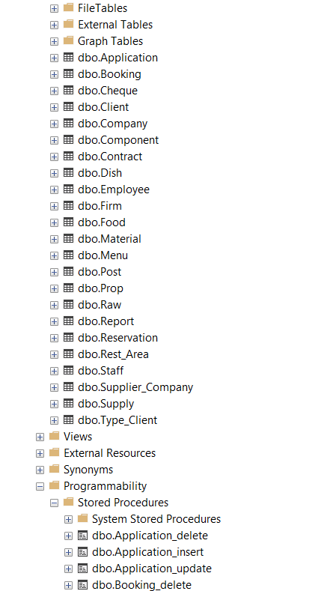

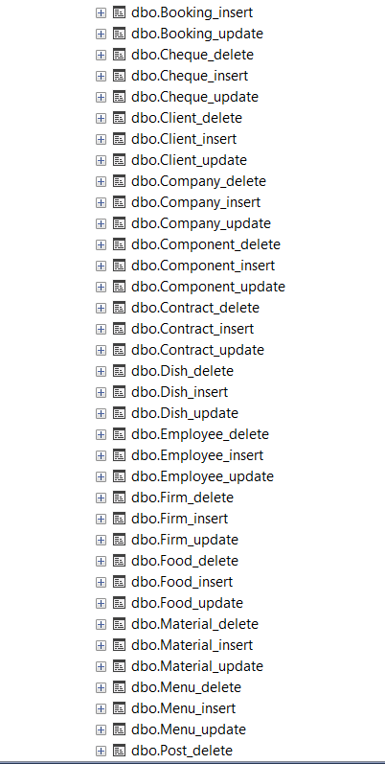

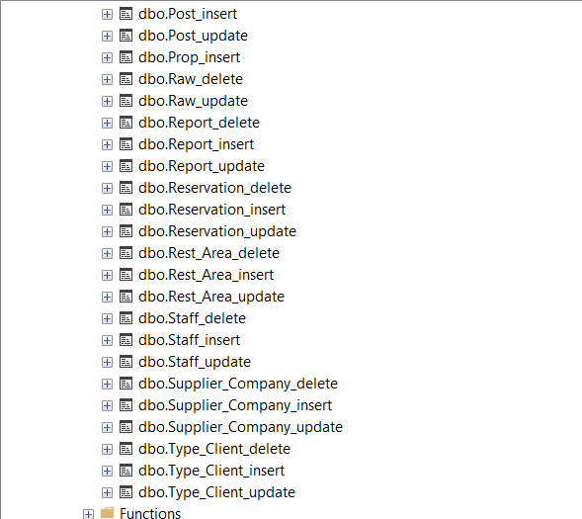

ВЫВОД

Я получил навыки, на основании проведённого анализа предметной области, а именно в проведении нормализации, приведение ненормализованной формы к 3НФ, применение свойств данных, которые подлежат хранению в базе данных к нормализации отношений, приведении отношений к структурированному виду, применение принципов и механизмов межтабличных связей.

1. СПИСОК ИСПОЛЬЗУЕМЫХ МАТЕРИАЛОВ

Пример этапов практической (Word, [задание](https://drive.google.com/file/d/1zYxKsKm5Ab-BnWJW_s2Mf3UT1uGUmMb6/view?usp=drive_web&authuser=1), [шаблон отчёта](https://drive.google.com/file/d/1Kc04FsjOh3HGFh_ZDjBzIs9-qh3YjYNP/view?usp=drive_web&authuser=1).